Software Requirements Specification
for
Smart Bite
Version 1.0

Prepared by
Group Name: SE5
Retaj Ali | 231005689 | Aretaj46@gmail.com
Rokaya Hamdy | 231006586 | Rokayahamdy80@gmail.com
Rawan Atef | 231005789 | Rawanatif9112004@gmail.com
Youssef Karim | 231014449 | Youssefkarim.fathy@gmail.com
Youssef Mahmoud | 231006058 | Youssefmahmoudmostafa559@gmail.com
Mahmoud Samer | 231006523 | Mahmoud.samer2005@gmailcom

Instructor: | Dr Nada Mahmoud
Course: | Software Requirements and Specifications
Teaching Assistant: | ENG. Maha Talaat
Date: | 10/12//2025
Contents
Contents ii
Revisions ii
1 Introduction 1
1.1 Document Purpose 1
1.2 Product Scope 1
1.3 Intended Audience and Document Overview 1
1.4 Definitions, Acronyms and Abbreviations 1
1.5 Document Conventions 1
1.6 References and Acknowledgments 2
2 Overall Description 2
2.1 Product Overview 2
2.2 Product Functionality 3
2.3 Design and Implementation Constraints 3
2.4 Assumptions and Dependencies 3
3 Specific Requirements 4
3.1 External Interface Requirements 4
3.2 Functional Requirements 4
3.3 Use Case Model 5
4 Other Non-functional Requirements 6
4.1 Performance Requirements 6
4.2 Safety and Security Requirements 6
4.3 Software Quality Attributes 6
5 Other Requirements 7
Appendix A – Data Dictionary 8
Appendix B - Group Log 9

Revisions
Version | Primary Author(s) | Description of Version | Date Completed
1.0 | Retaj Ali, Youssef Karim, Rokaya Hamdy, Rawan Atef, Youssef Mahmoud, Mahmoud Samer | Initial full version of the Software Requirements Specification for SmartBite – AI Recipe Maker. Includes introduction, requirements, use cases, and non-functional specifications. | 11/12/2025

Introduction

Document Purpose
Smart Bite is an AI-driven recipe maker created to transform ordinary kitchen ingredients into practical, healthy meals. By combining a camera-based ingredient scanner with an intelligent recipe engine, it solves the everyday question: “What should I cook?”, Instead of guiding users on what to buy or offering professional dietary plans, Smart Bite focuses on a clear purpose of connecting the ingredients people already have to meals they can make.
This app is designed for students, busy professionals, families, and anyone short on time or cooking experience, Smart Bite reduces food waste, saves money, encourages healthier eating habits and simplifies decision-making by instantly turning available items into cost-effective, nutritious recipes.

Product Scope

Smart Bite is not designed to replace the grocery store, meal delivery services or professional nutrition counselling. Instead, its role is focused & clear: to help users make the most of what they already have at home. The product directly addresses common problems like wasted groceries, limited cooking skills and lack of time to plan meals.

The project is limited to converting the user’s existing ingredients into ready-to-cook recipes. It does not include external integrations such as online stores or health tracking services. These boundaries ensure that Smart Bite stays focused on its core purpose; bridging the gap between a cluttered fridge and a finished dish — while preventing scope creep

Intended Audience and Document Overview
This document is intended for developers, testers, instructors, and stakeholders who are involved in the design and implementation of SmartBite. It includes system descriptions, requirements, use cases, and quality attributes organized according to IEEE standards.

Definitions, Acronyms and Abbreviations
AI – Artificial Intelligence
UI – User Interface
DB – Database
FR – Functional Requirement
NFR – Non-Functional Requirement
SRS – Software Requirements Specification

Document Conventions
All requirements are numbered as FR-x for functional and NFR-x for non-functional. Arial font size 11 is used with single spacing. Headings follow IEEE formatting.

References and Acknowledgments
From Section and lectures

Overall Description

Product Overview
SmartBite is a mobile and web app that interacts with users, a recipe database, advertisers, and an AI model. Users provide ingredients, and the AI model generates recipes and nutritional details. The app supports subscriptions for ad-free use and allows sharing and saving recipes.

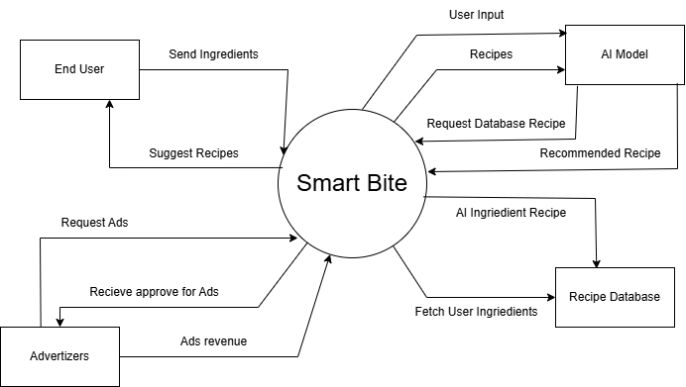

Product Functionality
• Login and Register
• Access Camera and Gallery
• Detect Ingredients
• Generate Recipes
• Display Nutrition Facts
• Save, Share, Sort, and Filter Recipes
• Subscribe to Remove Ads
• Manage Advertisements and Revenue

Design and Implementation Constraints
The system must be implemented using UML modeling and adhere to the COMET design method for proper software structure. The app must comply with data privacy and security regulations.
The app must run on Android 10 or higher. All design and code must be completed using open-source tools. The system should be designed to generate recipe results within ten seconds and must comply with modern data protection regulations. It relies on a stable internet connection and external APIs for AI processing and nutritional data retrieval.

Assumptions and Dependencies
Assumptions
- Users will have access to smartphones with working cameras.
- Users will have a stable internet connection when using the app.
- The image recognition API will function accurately and consistently.
- Required datasets (ingredients, recipes) will be provided or found online.
- Team members will be available throughout the project period.
Dependencies
- Recipe generation feature depends on the ingredient recognition model being trained and tested.
- UI design depends on finalizing the list of core features.
- App launch depends on approval from the Google Play Store and App store.
- Ingredient detection accuracy depends on the quality of the photo scanner.

Specific Requirements

External Interface Requirements

User Interfaces
SmartBite will feature a modern, user-friendly interface that includes a home screen, camera upload page, and recipe results screen. Users can easily navigate between sections to input ingredients, view recipe suggestions, and check nutritional information.

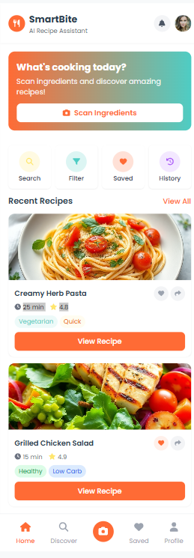

Hardware Interfaces
The application requires access to the device’s camera for ingredient scanning and the gallery for image selection. It also utilizes basic device storage to save user preferences and recipe history.

Software Interfaces
SmartBite interacts with the internal recipe database, AI model API for image recognition and recipe generation, and advertisement modules for displaying or removing ads.

Functional Requirements
ID | Description | Priority
FR-01 | The System should allow Users to Login or Register. | Medium
FR-02 | The System should allow Users to Logout or delete accounts. | Medium
FR-03 | The System should allow Users to edit on their accounts. | Medium
FR-04 | The System should ask Users to give access to the camera and gallery. | High
FR-05 | The AI photo scanner should detect ingredients. | High
FR-06 | The AI photo scanner should generate recipes. | High
FR-07 | The System should show detail of recipes. | Medium
FR-08 | The System should allow Users to share and filter. | Low
FR-09 | The Users have the option to subscribe to remove ads. | Medium
FR-10 | The admin should be able to monitor User activity and usages statistics and feedback. | High
FR-11 | The admin should be able to manage refunds requests, subscription and ads. | High

Use Case Model

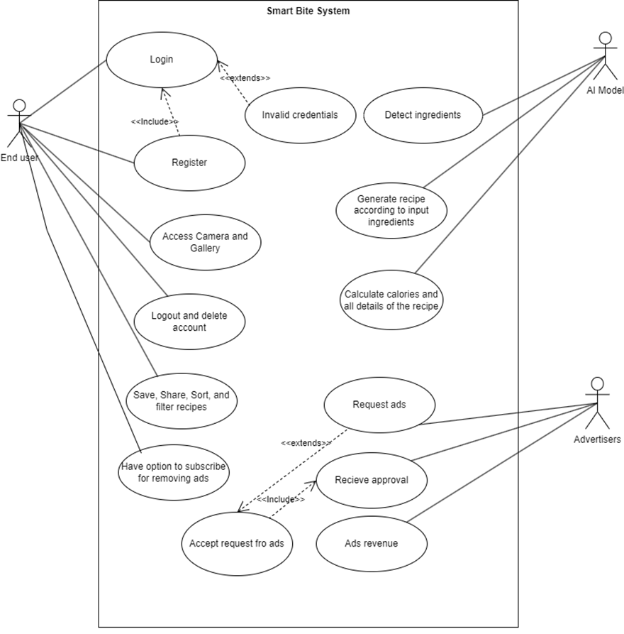

Use Case #1 (UC-1 Login)
Use case ID & Name: UC-1 Login
Primary Actor: End User
Secondary Actors: System, Database
Author: Retaj Ali, Youssef Mahmoud
Purpose: The purpose of this use case is to allow an existing user to log into the SmartBite application using their email and password so they can access their personalized features and data.
Requirements Traceability: This use case is related to FR-01 (The system should allow Users to Login or Register).
Priority: Medium – The login use case is essential because users must be authenticated before they can use the core functions of the system.
Preconditions: The user already has an existing account.
Postconditions: The user is logged in and can access their personalized features.

Actors:
- End User
- System
- Database

Extends:
None.
- Flow of Events
1. Basic Flow
- User opens the app
- Enter the email password
- System checks the credentials in the database
2. Alternative Flow
A1. If the email or password is incorrect, an error message appears.
A2. If the account is locked, the user is asked to reset their password.
3. Exceptions
E1. If the database is not available, the system cannot complete the login and shows a general error message.
Includes (other use case IDs):
- UC-2 Register (for users who do not have an account and need to create one).
Notes/Issues:
Two-factor authentication or biometric login (fingerprint/face ID) can be added in future versions as an extension to this use case.

Use Case #2 (UC-3 Access Camera and Gallery)
Use case ID & Name: UC-3 Access Camera and Gallery
Primary Actor: End User
Secondary Actors: Device
Author: Rokaya Hamdy, Youssef Karim
Purpose: The purpose of this use case is to allow the user to either capture a new photo using the device camera or select an existing image from the gallery, so the SmartBite application can detect and analyze the ingredients for recipe generation.
Requirements Traceability: This use case is related to FR-04 (The system should ask users to give access to the camera and gallery) and FR-05 (The AI photo scanner should detect ingredients).
Priority: High – Accessing the camera and gallery is essential for collecting image input, which is the foundation of the AI ingredient-detection feature.
Preconditions: The user is logged in and has granted permission to access the camera or gallery.
Postconditions: The selected or captured image is uploaded or available for use in the app.
Actors:
- End User
- Device
Extends:
None.
- Flow of Events
1. Basic Flow
- User chooses to upload or capture an image.
- System opens the camera or gallery.
- User selects or takes a photo.
2. Alternative Flow
A1. If permission is not granted, the system asks for camera or gallery access.
A2. If upload fails, the system shows an error message.
3. Exceptions
E1. If the device camera is unavailable or crashes, the system informs the user that the action cannot be completed.
E2. If the image format is unsupported, the system displays a warning and asks the user to choose a different file.
Includes (other use case IDs):
UC-7 (Detect Ingredients) – Triggered after the image is successfully uploaded.
Notes/Issues:
The system should remember the user’s permission preferences and only prompt again if permissions are revoked. Future enhancements may include drag-and-drop uploads and automatic image compression to speed up processing.

Use Case #3 (UC-8 Generate Recipe)
Use case ID & Name: UC-8 Generate Recipe
Primary Actor: AI Model
Secondary Actors: End User
Author: Rawan Atef, Mahmoud Samer
Purpose: The purpose of this use case is to allow the SmartBite AI model to analyze the list of ingredients provided by the user and automatically generate relevant, nutritious, and easy-to-follow recipes. This functionality helps users make the most of the ingredients they already have at home, reducing food waste and saving time in meal preparation.
Requirements Traceability: This use case is related to FR-06 (The AI photo scanner should generate recipes) and FR-07 (The system should show details of recipes), as well as NFR-01 and NFR-02 (performance requirements for fast generation).
Priority: High – Recipe generation is the core function of SmartBite. Without this feature, the main objective of the system cannot be fulfilled.
Preconditions: The user is logged in and entered the ingredients.
Postconditions: The AI model generates a recipe based on the given ingredients.
Actors:
- AI Model
- End User
Extends:
None.
- Flow of Events
1. Basic Flow
- User enters available ingredients.
- User clicks “Generate Recipe”.
- The AI model processes the input and shows recipe suggestions.
2. Alternative Flow
A1. If the input is incomplete, the system asks the user to add more ingredients.
A2. If the AI model fails to generate, an error message appears.
3. Exceptions
E1. If the database connection is lost, the system cannot retrieve recipe data and notifies the user to try again later.
E2. If the AI model receives unrecognized or invalid ingredient names, the system displays a message requesting valid input.
Includes (other use case IDs):
UC-7 (Detect Ingredients) – Provides the list of ingredients used in recipe generation.
Notes/Issues:
The accuracy of recipe generation depends on the quality and completeness of the input ingredients. Future versions may include personalized recommendations based on user preferences, dietary restrictions, or calorie goals.

Other Non-functional Requirements

Performance Requirements
ID | Category | Requirement
NFR-01 | Performance | The AI photo scanner must scan photo within 10 seconds.
NFR-02 | Peformance | The AI recipe generation must be under 10 seconds.

Safety and Security Requirements
ID | Category | Requirement
NFR-03 | Security | Users Data must be encrypted.
NFR-04 | Security | Database must have encryptions.
NFR-05 | Security | The System must support 2FA.

Software Quality Attributes
ID | Category | Requirement
NFR-01 | Performance | The AI photo scanner must scan photo within 10 seconds.
NFR-06 | Reliability | The System should maintain an uptime of 98% per month.
NFR-07 | Reliability | If a critical service fails a backup service should be available within 60 seconds.
NFR-08 | Scalability | The System should be able to withstand 5000 Users at once.
NFR-09 | Usability | Interface must be consistent, Modern and easy to understand.
NFR-10 | Usability | Error messages must be clear.
NFR-11 | Usability | AI must be able to detect rotten ingredients
NFR-12 | Compatibility | The System must be available on android, IOS and Web.

Other Requirements
Smart Bite must follow data privacy and security rules to keep user information safe. The system should be easy to update and expand in the future, such as adding new features like more languages or diet options. It should also be accessible to all users and work well with trusted third-party services or APIs.

Appendix A – Data Dictionary
Item | Type | Description
Ingredient | Input | The list of items detected or entered by the user for recipe generation
Recipe | Output | A set of cooking instructions and nutritional details generated by the AI model
User | Entity | Contains login, subscription, and saved recipe information
AI Model | Process | The module that analyzes ingredients and produces recipe suggestions

Appendix B - Group Log
Date | Activity | Members
26/10/2025 | Conducted user interviews to gather functional and non-functional requirements | Retaj, Youssef
15/11/2025 | Created system diagrams and functional requirement lists | Full team
02/12/2025 | Updated UI and integrated elicitation feedback | All members
09/12/2025 | Finalized and approved SRS Version 1.0.1 | Entire group

